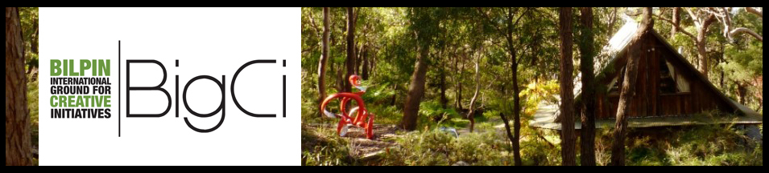
The BigCi Environmental Award 2014
Australian and International artists are invited to submit entries for the inaugural
BigCi Environmental Award 2014:
- 2 weeks artist residency at BigCi
Submission deadline is the 3rd of March 2014.
See www.bigci.org for more information about BigCi.
Submission Criteria
The BigCi Environmental Award is available to artists from various fields such as painters, sculptors, installation artists, multimedia artists, performance artists, writers, musicians, filmmakers and curators.
Your submissions must address two key criteria, in line with our focus on the Environment around BigCi and the Professional Development of the artists:
- Show how you wish to respond to the Environment around BigCi. We are located on the edge of Wollemi National Park in the World Heritage listed Greater Blue Mountains, about one and a half hours drive from Sydney. You can choose to deal with a particular environmental issue, explore ideas and concepts related to nature, or use this opportunity to deepen your knowledge of the unique wilderness on BigCi’s doorstep.
- Show how your Professional Development will be advanced by the time you will spend at BigCi. Proposals can be made for the further development of current projects or for creating new initiatives.
The recipients of the Award will stay for two weeks at BigCi during a mutual agreed time within 12 months after receiving the Award. The Award can be split between collaborators or used to contribute to a longer stay self-funded by artists.
The Award will be judged by an independent panel consisting of Tia McIntyre, Curator, Hawkesbury Regional Gallery and Michael Keats, Author and Explorer. The judges reserve the right not to grant an Award if the calibre of the applications is not deemed suitable. The judges’ decision is final.
The Residency
BigCi provides shared accommodation and work spaces for creative and professional development in a beautiful and tranquil environment, as well as artist support and project facilitation. The residency includes accommodation, workspace, the use of shared living facilities, bathroom, kitchen, internet, electricity, water.
Artists will be responsible for all other costs including food, transport, travel costs, insurance and art materials. They will be required to pay a refundable bond prior to occupancy to cover any costs associated with damage or extraordinary cleaning.
Due to a remote location of BigCi, a car is strongly recommended. If this is not possible, we offer pick up from Richmond train station and once a week food shopping trip.
BigCi Environmental Award 2014 Application Form

Applicant’s full name: ______________________________________________________
(If this is a group application, please fill in separate form for each applicant)

Artistic name, if applicable:____________________________________________________________

Street address: __________________________________________________________________

Postal address: ___________________________________________________________________

Suburb/town: _____________ State: _____________ Post code: ________________

Country _________________________________________________________________________

Phone: _____________________ Mobile: __________________________________________

Email: ______________________________ Website: __________________________________

How did you find out about this Award? _________________________________________________

When would you prefer to undertake the residency? (Please give 2 options)__________________________ _____________________________________________________________________________________

The residency can take place between May 2014 and May 2015. The Award covers two weeks of residency. The artist(s) can stay longer at an additional cost.

What do you propose to do during your residency and how will your work respond to the Environment around BigCi (see first of the Submission Criteria)? Maximum of 250 words. _________________________________________________________________________________________________________________________________________________________________________________________________________________________________________________________________________________________________________________________________________________________________________________________________________________________________________

How will your Professional Development be advanced by the time you spend at BigCi (see second of the Submission Criteria)? Maximum of 250 words. _______________________________________________________________________________________________________________________________________________________________________________________________________________________________________________________________________________________________________________________________________________________________________________________________________________________________________

Special work requirements for your project (if applicable):
(For example describe how much space you need, if you will bring tools, whether you will work indoors or outdoors and any other information that would be helpful to accommodate your needs.)
_______________________________________________________________________________________________________________________________________________________________________________________________________________________________________________________________

Submissions checklist:

1. Application form
2. CV
3. Examples of your previous work (no more than 5 MB in total).

If you are not successful in receiving this Award, would you still be interested in undertaking a self- funded residency at BigCi? Yes/No

__________________________________________________________________________________

Please email your entry to sculptor@raebolotin.com by the Award submission deadline 3rd March 2014 .

Entries will be reviewed as they are received. Please try to send your entry earlier.

The successful applicants will be notified in writing by 30th March 2014.

Thank you for submitting your entry.

For any queries, please contact Rae Bolotin at sculptor@raebolotin.com

